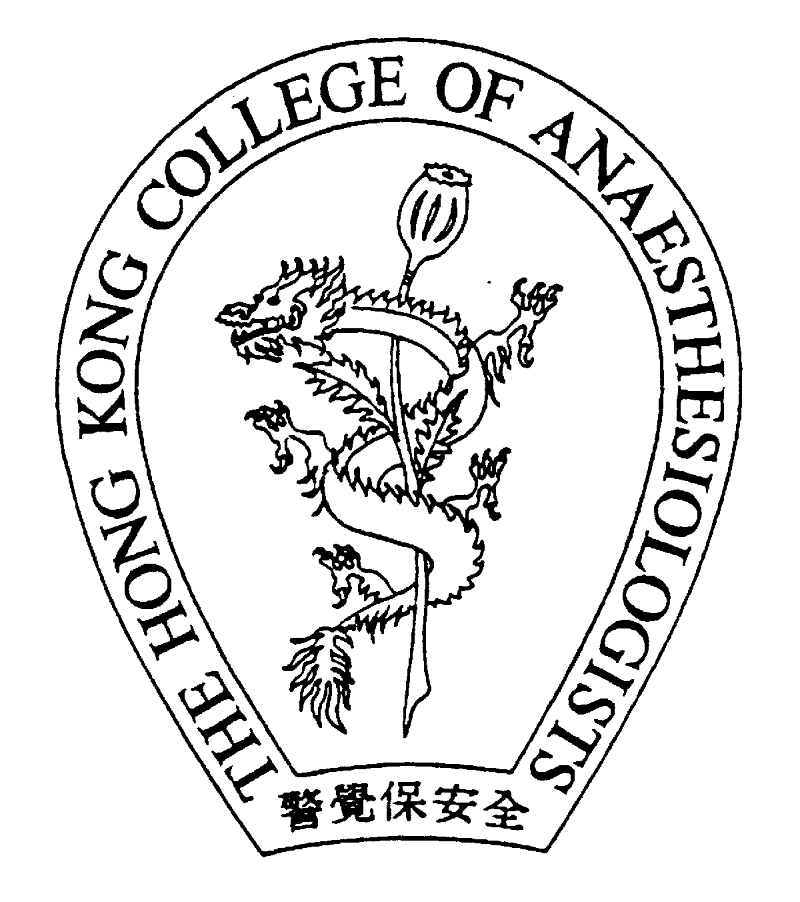
Hong Kong College of Anaesthesiologists
Board of Education

Trainee Training Statistics Form

Core areas in anaestheisa
Subspecialty anaesthesia | Numbers of cases claimed
General surgery /urology /gynaecology
Orthopaedics and traumatology
Obstetric anaesthesia
Obstetric regional analgesia
Neuroanaesthesia
Thoracic anaesthesia
Paediatric anaesthesia (Children < 6 yrs)
Head & Neck / ENT/ Oro-facio-maxillary
Emergency / trauma anaesthesia
Acute pain management
Non-core modules
Category 1
Ophthalmic anaesthesia
Day surgery anaesthesia
Anaesthesia in non-operating theatre locations
Pain medicine (chronic / cancer pain cases)
Category 2
Major vascular anaesthesia
Cardiac anaesthesia
Transplant anaesthesia
Neonatal anaesthesia (Child< 1 month)

I declared that the information is correct to the best of my knowledge.
_____________________________(________________)  Trainee Signature and Name | ___________________  Date

Submitted via SOT:
_____________________________(________________)  Supervisor of Training Signature and Name | ___________________  Date

NOTES:
This form needs to be submitted to the Training Officer of the Board of Education before the Exit Assessment for trainee who applies for the Exit Assessment after 1st January 2008. A Vocational Training Completion letter will be issued to the trainee if his/her Clinical Anaesthesia experience meets the subspecialties requirement below and has completed 48 months of Clinical Anaesthesia, 15 months of Elective Training, 3 months of Intensive Care and 6 months of non-anaesthetic training .

The Clinical Anaesthesia experience must include an adequate exposure to all of the following CORE areas in anaesthesia. To ensure adequate exposure, a trainee is expected to have managed a minimum number of cases in each core subspecialty (as defined in the brackets) over the 6 years of training
- Anaesthesia for general surgery /urology /gynaecology (500 cases)
- Anaesthesia for orthopaedics and traumatology (500 cases)
- Obstetric anaesthesia (100 cases) and obstetric regional analgesia ( 50 cases)
- Neuroanaesthesia (100 cases)
- Thoracic anaesthesia (50 cases)
- Paediatric anaesthesia (100 cases of children < 6 years, including neonates)
- Anaesthesia for Head & Neck / ENT/ Oro-facio-maxillary (100 cases)
- Emergency / trauma anaesthesia (500 cases)
- Acute pain management (300 patient-days)

Apart from the CORE areas, some experience in each of the following NON-CORE subspecialties1
would be required, particularly for future subspecialty development. Trainees will be required to
complete two modules from category 1 and a minimum of 20 cases from category 2.
Category 1 NON-CORE modules
- Ophthalmic anaesthesia (50 cases)
- Day surgery anaesthesia (100 cases)
- Anaesthesia in non-operating theatre locations including but not limited to Organ
Imaging Suite, Endoscopy Suite, Cardiac Catheterisation Laboratory, ECT (50 cases)
- Pain medicine (50 chronic / cancer pain cases)
Category 2 NON-CORE Modules
- Major vascular anaesthesia
- Cardiac anaesthesia
- Transplant anaesthesia
- Neonatal anaesthesia

