ORDER FORM
Ordering Form for Anniversary Medal (in flocky box) celebrating

Silver Jubilee of The Hong Kong College of Anaesthesiologists
Diamond Jubilee of The Society of Anaesthetists of Hong Kong

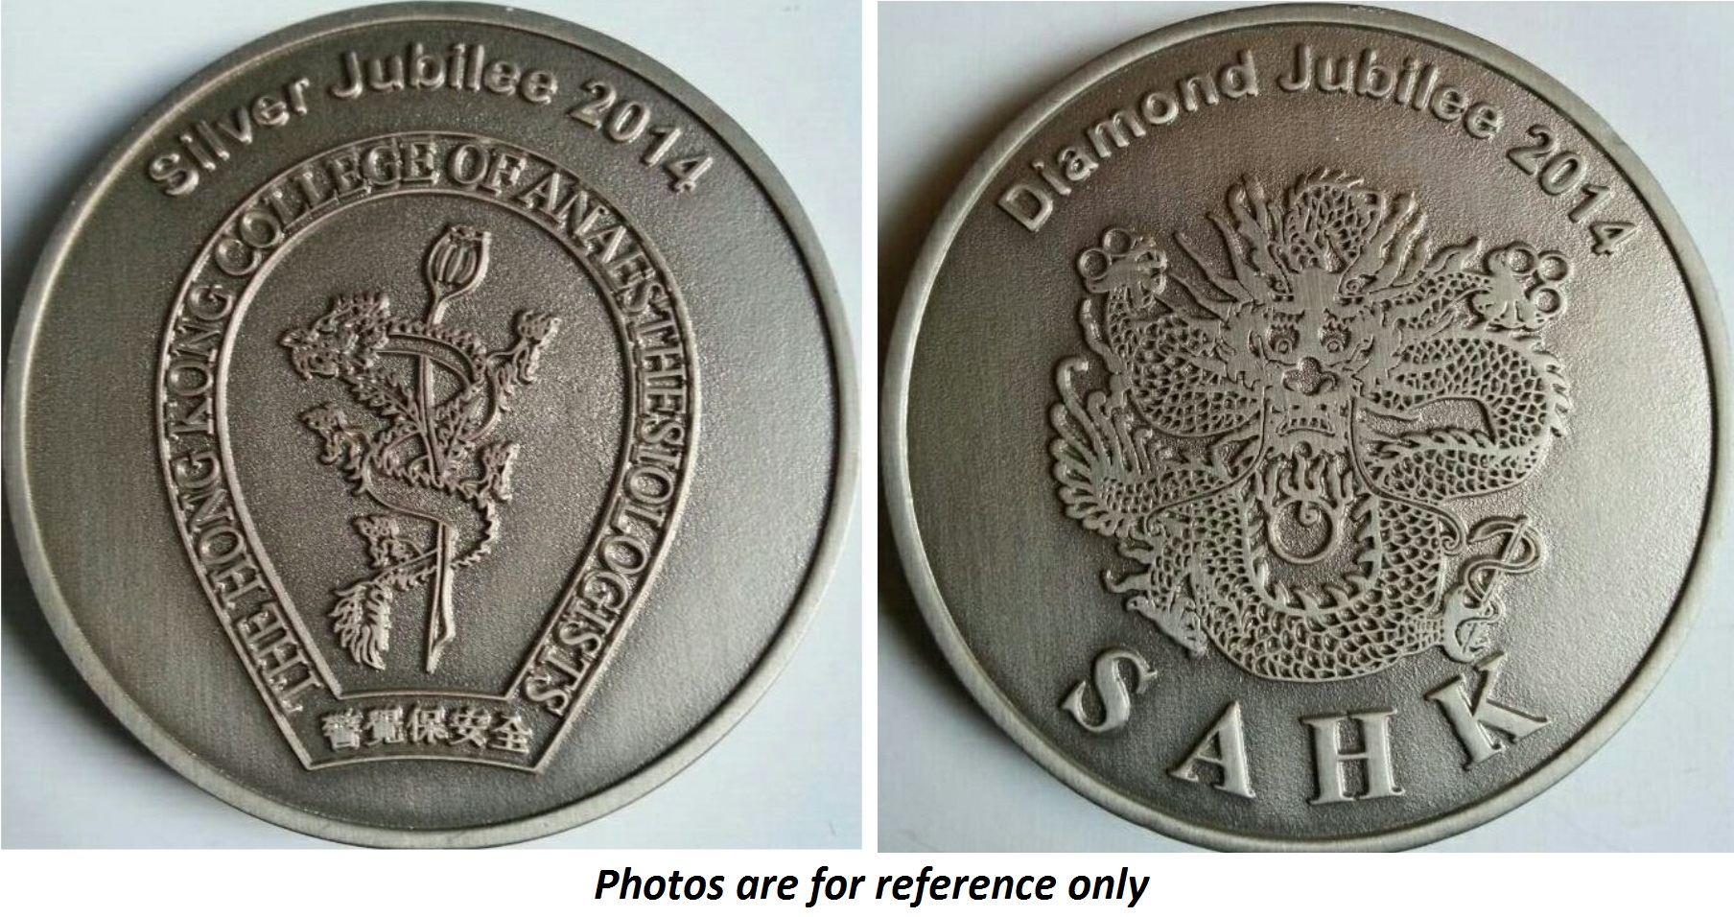

Size : 55mm in diameter
Weight : 80g
Color : Pewter
Price : HK$160.0 (to be collected at HKCA Office)
Add HK$30.0 of delivery charge in HK by registered post

For international shipping charge, please contact HKCA Office at (852)2871 8833 or fax this form to us at (852) 2814 1029 for information.
-------------------------------------------------------------------------------------------------------------------------
To: HKCA Date:_______________

Description | Unit cost | Quantity | Total (HK$)
Anniversary Medal | HK$160
Shipping cost per medal (local, registered mail) | HK$30
Total Amount :

Name of Member / Fellow : _________________________________________________(Title, Surname, Given Name)

Correspondence address (if delivery is required):

________________________________________________________________________________________________

________________________________________________________________________________________________

Tel : Email: ______________________________________________

Please send the form together with cheque payable to “The Hong Kong College of Anaesthesiologists” on or before 31 December 2014 to :

Room 807, HKAM Jockey Club Building, 99 Wong Chuk Hang Road, Aberdeen, Hong Kong.

Note: The medals are produced in limited numbers and it will be sold on a first-come-first-served basis. Orders per Fellow/ Member for more than 2 medals will not be accepted. No orders will be accepted after 31 December 2014. If no payment received after receiving order by 31 December 2014, the order will be forfeited.

